And may the source never run dry

American Friends of Florence Music
11 JUNE 2018,
FRANCESCA JOPPOLO
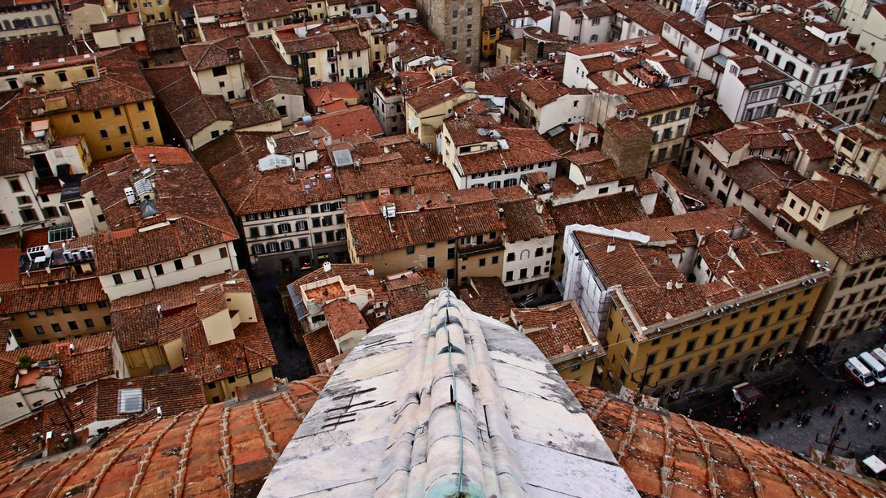
A stunning view of Florence
James Fox Miller is one of the top hundred divorce lawyers in the United States, a very tall and imposing man who certainly does not have the air of a delicate flower, even if his words can be very touching: “I know Barbara for sixty years, we have been married for fifty-seven of them, and no one loves me as she does. My wife is truly important to me, and everything else matters less.” In this era of frequent divorces, James and Barbara are happiest when they are together, to the point of even sharing the same work desk in their apartment so spacious that each could easily have a separate study. Their apartment is always filled with the sounds of music.
Jim Miller, as he is known to his friends, is a partner in the law firm Boies Schiller Flexner L.L.P., described by the Wall Street Journal as a “national litigation powerhouse.” One illustration: Two great lawyers, David Boies (the firm’s name partner and a liberal) and Ted Olson (a conservative from another firm), argued opposite sides in Bush versus Gore in 2000 (Bush prevailed.), but joined forces to combat anti-gay discrimination before the Supreme Court. Thanks to their brilliant abilities, same-sex marriage is now legal in all fifty of the United States. Boies’s commitment to civil rights, however, has not prevented him from representing corporate giants such as American Express, Delta Airlines, Lloyd’s of London, Nike, Sony Corporation of America, Barclays, BNP Paribas, Del Monte. He and Jim are colleagues and the best of friends.
Barbara Miller is a fund-raising guru active in the democratic politics of Florida, a key state in US elections. Seeming so small and fragile beside her husband, it is when she gazes directly at you with her light, expressive eyes that you see all her strength and determination. Although Barbara hails from Iowa and Minnesota, and Jim comes from New Jersey, the couple is based seven months a year in Florida.
Just like a pair of secret lovers, the Millers lead a second life, but one that can be open and officially acknowledged. That life is in Florence, where they spend five months each year. After much traveling in search of another “nest,” they decided that they prefer culture and a city to all the stunning, natural wonders of the world, but that city had to be Florence. Jim announced, “I love Florence,” and Barbara seconded the motion. Florence, called Florentia by its ancient Roman founders, comes from florere, to flower. Given that their American state of residence acquired its name from the Spanish pascua florida, celebration of flowers, there must be some attraction to petals and blossoms chez Miller. They also have a passion for music which they share with Jeff Thickman, a pianist, former musicologist at Columbia University and for decades a Florentine citizen. Together, in December 2017 after two years of reflection, evaluation and the invaluable pro bono legal work of the Boies, Schiller, Flexner firm, they founded American Friends of Florence Music, a non-profit organization that in its first three months of existence has already received 130,000 dollars (with donors making a 3-year commitment pledge, thanks to the foresight of Jim) in the United States to be directed towards Florence’s concert seasons.
“Florence is the source of so much greatness and creativity,” explains Jeff Thickman, who was Cordon Bleu trained, the personal chef of Zubin Mehta for twenty-five years, and whose culinary treats have delighted stars like Sophia Loren, Gregory Peck, Daniel Day Lewis, Kirk Douglas, Walter Matthau and Frank Sinatra. “When I was teaching at Columbia, I would talk to my students about Florence. Now, I brim with emotion when I pass in front of Palazzo Bardi, the birthplace of Italian opera, and stop to think that it all started here. In Florence, you can experience opera where it was created, you can drink from the font of music in all its vibrant reality. It’s not surprising that many musicians of international renown have chosen to live here.”
Jeff is on the board of the Muriel and Seymour Thickman Family Foundation that supports, among other projects, providing classical music concerts to many remote towns of his native Wyoming. When the idea of creating American Friends of Florence Music was floated, he wondered aloud why an American would contribute money to music in Florence. Barbara, who is well-versed in the psychology of fund-raising, had a ready answer, “For the pride of our common cultural heritage with Florence as one of its main sources,” to which Jeff added, “And if that source were to dry up, the loss would be irreparable for all.”
Barbara spends Saturday afternoons in the Teatro della Pergola with Jim at her side listening to the Amici della Musica chamber music concerts and admiring the refinement and the knowledge of the Italian audience. When the Millers spontaneously offered their financial support to the chamber organization, the response was one of joyous bewilderment. Jeff explained the reaction, “In America it is normal for private individuals to finance culture. In Italy, however, it is the State, an omnipresent but intangible entity, that historically provided most of the financial support. It would be difficult to change that mentality.”
The three Americans are heirs to the dense colony of Anglo-Saxons who, from the times of the Grand Tour, chose Florence as their ideal home, a sort of present-day Parnassus, where art merges with daily life and permeates every architectural detail and blade of grass. Even during a simple walk to the post office (Could anything be more banal?) one can be struck by an unexpected spark of uplifting beauty. The Millers are gracious hosts in Florence. During our meeting, Debra DiMaggio, a well-connected Chicago lawyer and close friend of Quincy Jones, dropped by and immediately offered her maximum collaboration with American Friends of Florence Music.
Jim takes pride in showing the shelves of his bookcases packed to the brim with CD’s of a variety of musical genres. He is a huge fan of American musicals and knows them inside-out, but had he been born in Italy, would be equally mad about opera lirica. Here he spends his time listening predominantly to classical music, but still enjoys the rest, and he loves to read and learn more about music. From their bedroom window, Brunelleschi’s dome appears so near that it feels like a member of the household. “Is there any other place like Florence?” asks Jeff as he admires the stunning view.
Even if one must live far away, Florence always remains in the heart. Across the ocean, David Boies, the American super lawyer, is a major supporter of American Friends of Florence Music. And may the source never run dry.

Francesca Joppolo
Francesca Joppolo studied History of Art at Florence University, under Professor Roberto Salvini, and works as a professional journalist.

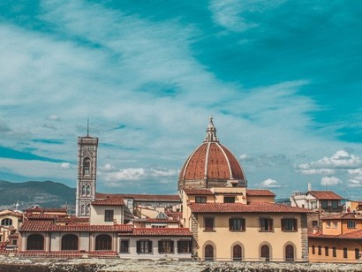

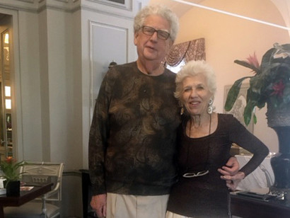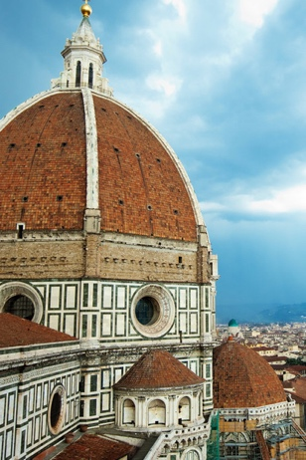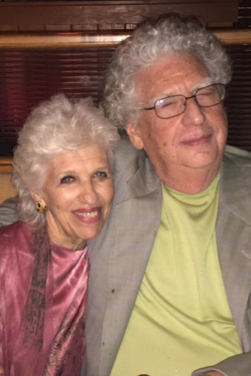

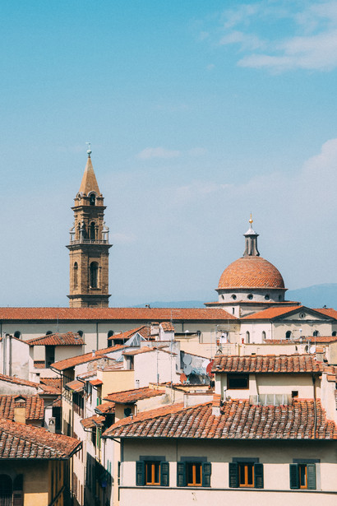
- Jeff Thickman
- View of Florence
- James Fox and Barbara Miller
- A passion for Florence
- James Fox and Barbara Miller
- The roofs of Florence

